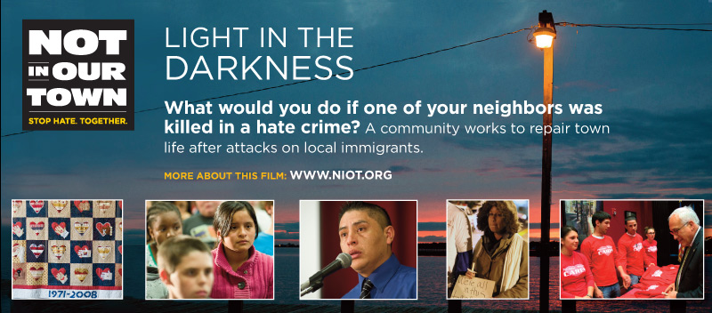
Not In Our Town: Light in the Darkness Production Bios
Patrice O’Neill, Executive Producer and Director
Patrice O’Neill is an award-winning producer dedicated to creating inspiring stories which spark audience members to become change agents in their own communities. As Executive Producer of the non-profit media company The Working Group (TWG), she has produced successful national series on PBS for fifteen years and led a multi-platform approach utilizing documentary film, grassroots engagement, educational outreach and social media to ignite dialogue and action. TWG’s 1995 special about a town responding to hate, Not In Our Town, set a standard for television impact and launched a movement that continues to thrive on the ground and at NIOT.org.
Adrienne Calo, Producer
Adrienne Calo is a Producer at The Working Group, contributing to the new film, Not In Our Town III: Light in the Darkness, as well as the related video series, Not In Our School. Before coming to TWG, Adrienne was the Series Producer of the Emmy-winning weekly arts magazine Spark for KQED-TV. As a writer and producer for television, Adrienne has also worked for PBS, The Discovery Channel, Court TV, and ABC News.
Charene Zalis, Producer
Charene Zalis is a Producer at The Working Group for the PBS film Not In Our Town: Light in the Darkness, the Not In Our School video series, and NIOT.org. Prior to joining TWG, Charene produced for the PBS human rights series Rights and Wrongs and Frontline, and as a freelancer based in Asia and the Middle East, she produced for Asia Business News, PBS and Nickelodeon. Charene began her career at NBC News and Sports where she was awarded an Emmy for a Muhammad Ali documentary, and produced features for the Olympic Games.
Ray Telles, Consulting Producer
Raymond Telles is a veteran producer of many award-winning programs including The Fight in the Fields, the biography of Cesar Chavez, Inside the Body Trade (National Geographic), Children of the Night (Frontline, PBS), and Race is the Place (PBS). He has produced and directed programs for ABC, NBC, PBS, Discovery, and National Geographic. Telles has won numerous awards including Emmy Awards, the DuPont-Columbia Gold Baton, PBS Programming Awards for News and Current Affairs, The Ohio State Award, ALMA Award, top honors in the San Francisco, Chicago and New York Film Festivals, as well as numerous other awards for his work in film and broadcast journalism. Telles is an Adjunct Assistant Professor in the Department of Ethnic Studies, U.C. Berkeley.
Linda Peckham, Editor
Linda Peckham is a freelance documentary editor in the Bay Area. She has cut programming for national and local broadcast since 1991, most recently Independent Lens' Emmy-nominated Tulia, Texas (2009), NOVA's Fabric of the Cosmos (forthcoming), PBS special Not In Our Town: Light in the Darkness (forthcoming), TPT's Make:TV, and The Fire Next Time (POV/Sundance Doc Fund, 2005). She has cut episodes for A&E Investigative Reports, Nova Science Now, WNET's Expose. She was the series editor of The Working Group's national series Livelyhood, 10 one-hour specials for PBS' Democracy Project, and series editor for four seasons of KQED's weekly art series Spark. She edits KQED's award-winning science series Quest, and has taught Aesthetics of Editing at BAVC. Linda has a BA in Film and an MFA in Writing, and has published essays in film journals and anthologies.
Jill Strong, Editor
Jill Strong is an editor for Not In Our Town. She worked on creating many of the pieces on NIOT.org as well as other videos for The Working Group. She graduated from the University of California, Santa Cruz with degrees in Community Studies and Journalism and has worked in the San Francisco Bay Area as a freelance video editor since 2005.
Andrew Gersh, Editor
Andrew Gersh is a documentary film and video editor based in Berkeley, California. His work has appeared on PBS, MSNBC, National Geographic, Discovery, Turner Broadcasting, Channel Four in the United Kingdom, and in movie theaters worldwide. He began his editing career on staff at WGBH Boston, where he worked on many groundbreaking series for PBS including NOVA, FRONTLINE, and the ten-hour WGBH/BBC co-production on the history of rock and roll. Recent projects include behind-the-scenes documentaries on the making of the Star Wars films for LUCASFILMS, Ltd., The New Heroes, a series on entrepreneurship for PBS through Oregon Public Broadcasting, segments for the PBS international documentary series FRONTLINE/WORLD, and many independent feature documentaries.
Brian Dentz, Principal Photography
Brian Dentz lives in Brooklyn, New York and works as a cameraman shooting
TV news and producing documentaries. Brian often works for television
news organizations from abroad, including ARD (German public TV) and
Fuji TV (Japanese TV.) He has also recently produced an independent
documentary called Duelo De Caballetes, which is showing in film
festivals this fall.

